Year 10 |  | Proportion | Calculator Allowed
Skills and Knowledge Assessed:  - Solve problems involving direct proportion. Explore the relationship between graphs and equations corresponding to simple rate problems (ACMNA208) |  |  | Name_________________
Section 1 Short Answer Section
Write all working and answers in the spaces provided on this test paper.
Calculators are allowed for this section.
A car travels at a constant speed of 110 km/h for a period of 1½ hours.
How far does it travel?

……………………………………………………………………………………………....

……………………………………………………………………………………………….
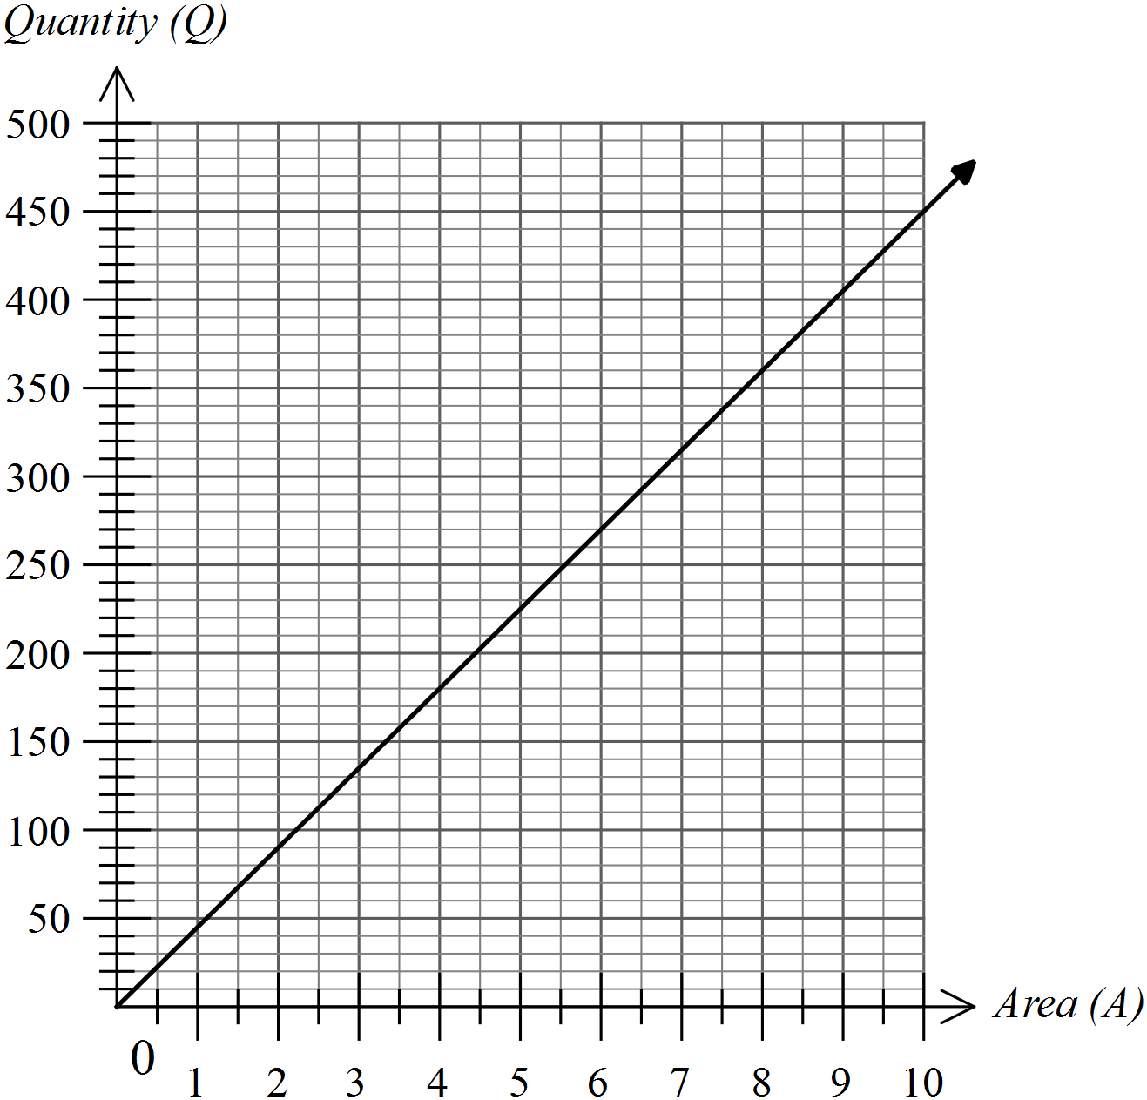Questions 2 and 3 refer to the following graph.
The graph shows the Quantity (Q litres) of liquid fertiliser recommended for use on a given Area (A ha) of farmland.

What amount of fertiliser would be needed for a paddock with area 8 ha?

……………………………………………………………………………………………....
What area of land could be fertilised with 200 litres of liquid fertiliser?

……………………………………………………………………………………………....
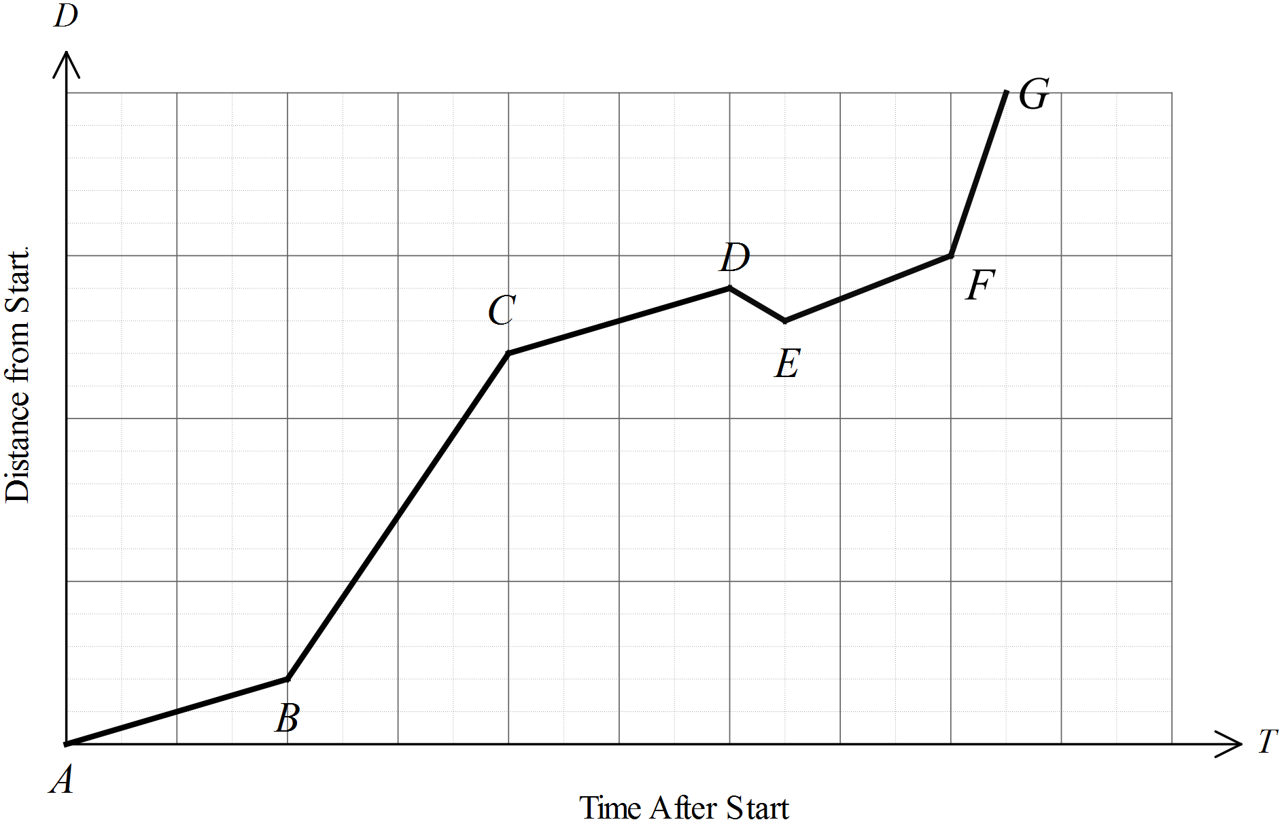Questions 4 and 5 refer to the following graph.
The distance/time graph shows a cyclist riding from point A to point G, passing through points B, C, D, E and F on the way.

Some sections of the ride are uphill and some downhill. Decide if the section from B to C is uphill or downhill and explain why you made this choice.

……………………………………………………………………………………………....

……………………………………………………………………………………………….
Give a description of what might have happened between D and E.

……………………………………………………………………………………………....

……………………………………………………………………………………………….
Between which two points did he travel fastest?

……………………………………………………………………………………………....

……………………………………………………………………………………………….
The cost of material bought off a roll is directly proportional to the length of the material.
Four metres of cloth cost $64.
Write an equation for the cost ($C) of L metres of cloth.

……………………………………………………………………………………………....

……………………………………………………………………………………………….
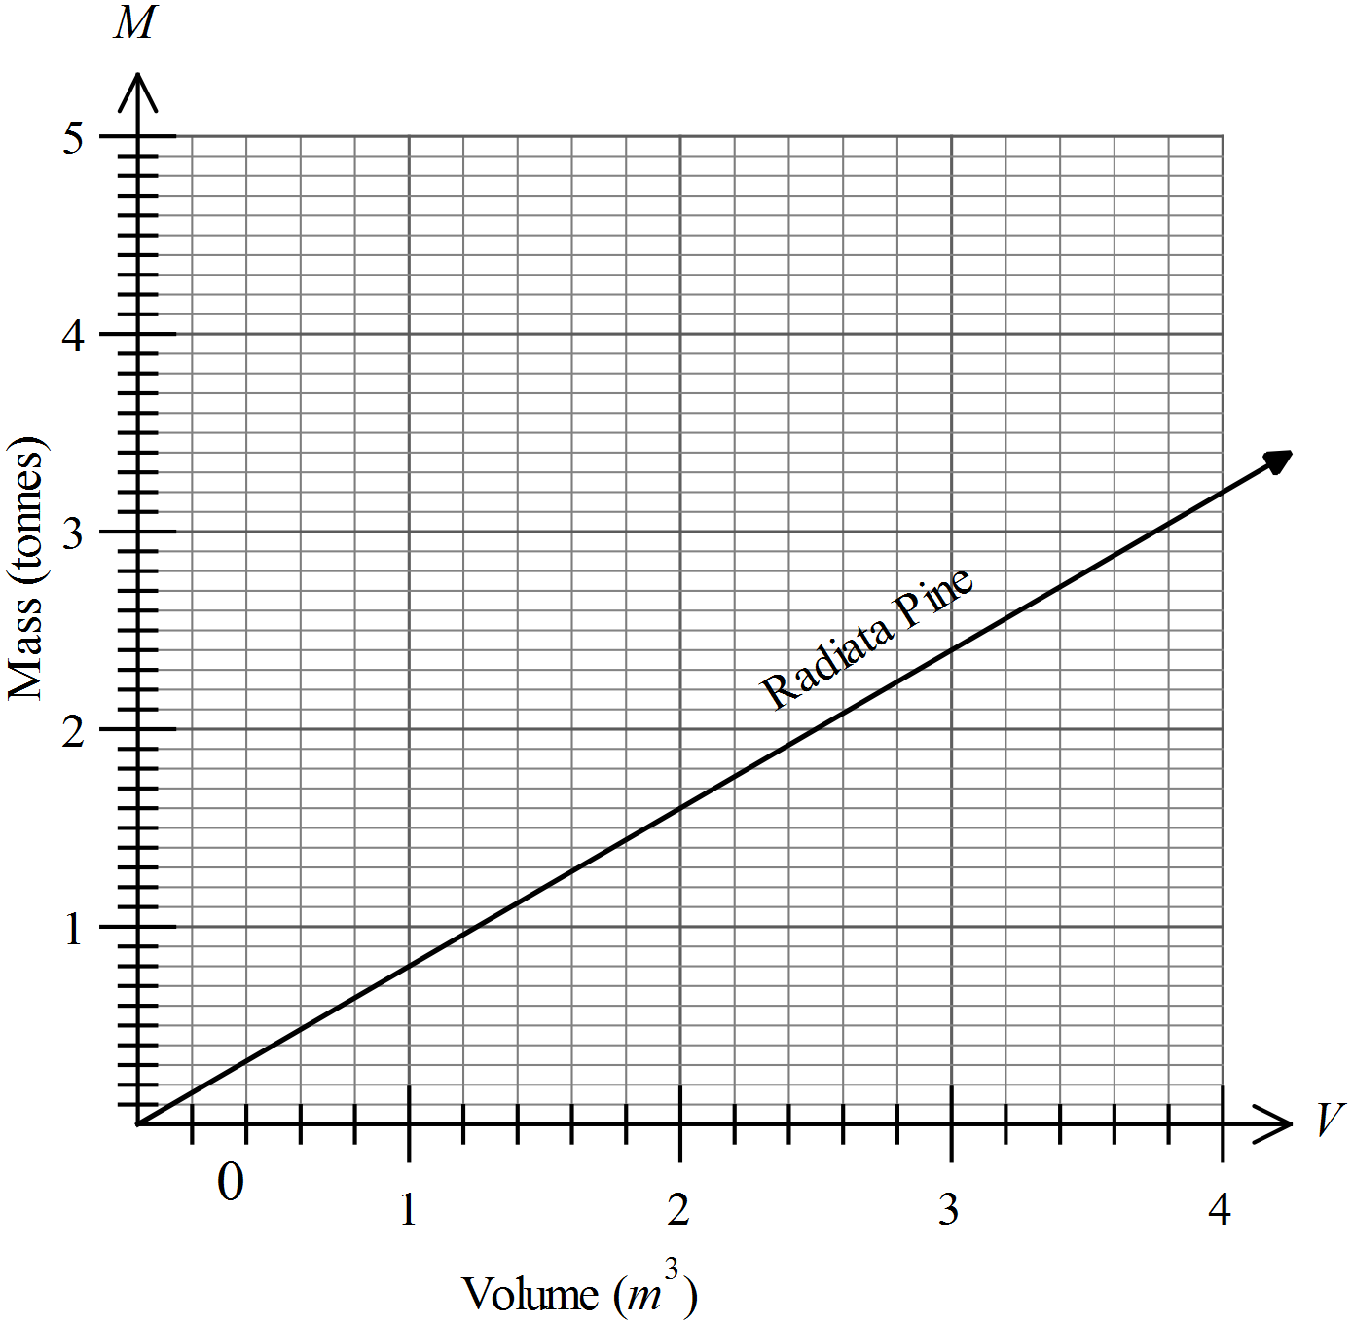Questions 8 – 10 refer to the following graph.
The graph shows the relationship between the Volume (V m³) of a timber species called Radiata Pine and the Mass (M tonnes) of the timber.

What is the mass of 2 m³ of Radiata Pine timber?

……………………………………………………………………………………………….
What is the equation of the relationship shown?

……………………………………………………………………………………………....

……………………………………………………………………………………………….
 | For another species of timber called Ironbark, 4 m³ has a mass of 4.8 tonnes. Draw and label the graph of the relationship for Ironbark on the grid.
Questions 11 - 14 refer to the following:
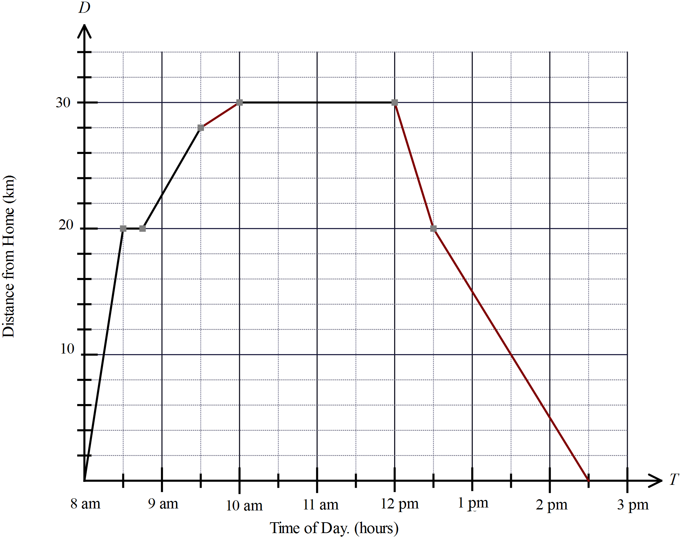The distance time graph represents Finn’s day out, travelling from home to a friend’s house and back.

What time did he arrive at his friend’s house and when did he leave?

……………………………………………………………………………………………….
On the way to his friend’s house, he caught two buses and walked part of the way.
At what speed did the faster of these buses travel?

……………………………………………………………………………………………....

……………………………………………………………………………………………….
How long did he have to wait between the buses?

……………………………………………………………………………………………....

……………………………………………………………………………………………….
On the way home he rode a bus for part of the way, then rode his skateboard for the remaining part of the journey. How much sooner would he have arrived home if he had ridden the bus all the way? (Assuming it travels at the same speed all the way.)

……………………………………………………………………………………………....

……………………………………………………………………………………………….
Questions 15 and 16 refer to the following.
The light intensity (I candelas) produced by a lamp is directly proportional to the current (C amps) passed through the lamp.
The relationship can be represented by the equation 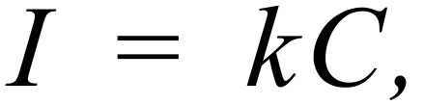 where k is the constant of proportion.

When the current is 20 amps, the light intensity is 45 candelas.
What is the value of the constant k?

……………………………………………………………………………………………....

……………………………………………………………………………………………….
What current would be needed to produce an intensity of 81 candelas?

……………………………………………………………………………………………....

……………………………………………………………………………………………….
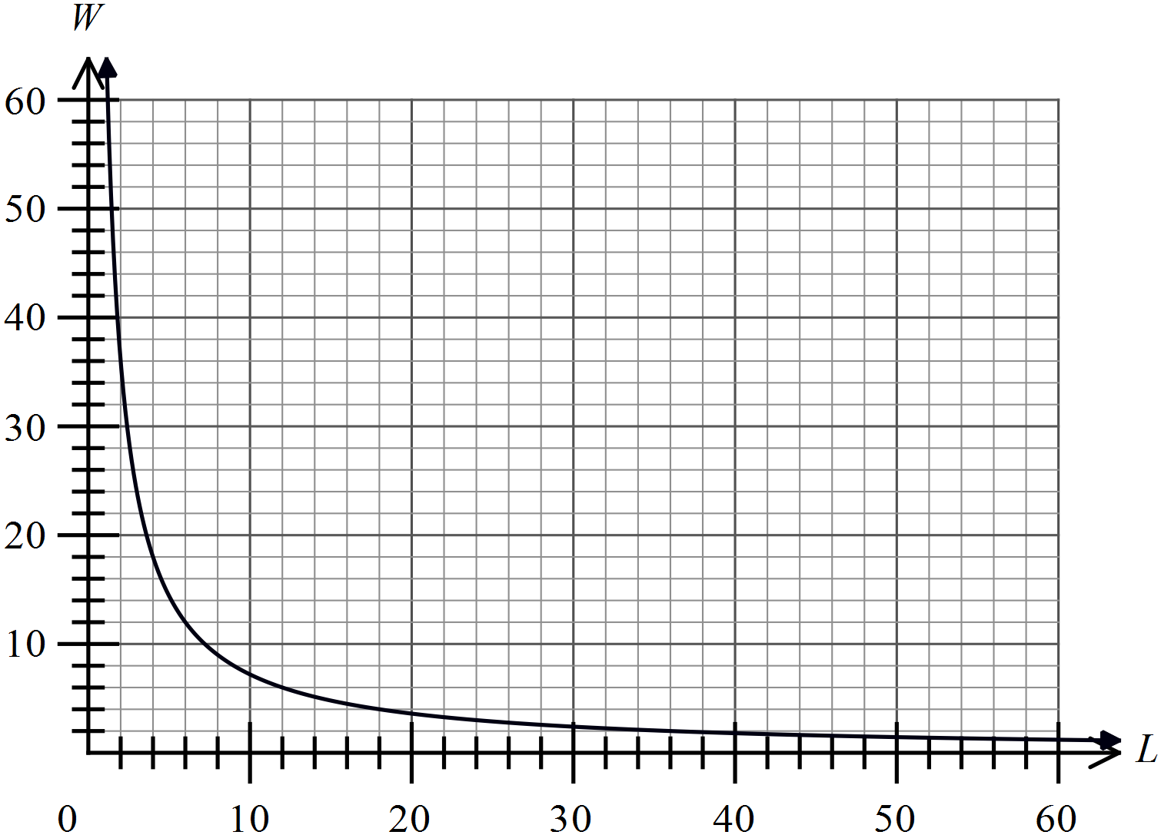Question 17 and 18 refer to the following graph.
A rectangular plot of ground is needed which has an area of 72 m².
An inverse proportion graph which compares the length and width of the plot is drawn.

If the plot must be at least 2 metres wide, give the dimensions of two possible rectangular plots.

……………………………………………………………………………………………....

……………………………………………………………………………………………….
Write an equation that describes the relationship between the length and width.

……………………………………………………………………………………………....

……………………………………………………………………………………………….

Year 10 |  | Proportion | Calculator Allowed
 |  | Proportion | Name_________________
Section 2 Multiple Choice Section
Mark all your answers on the accompanying multiple choice answer sheet, not on this test paper. You may do any working out on this test paper. Calculators are allowed for this section.

The amount (A litres) of fuel consumed on a journey is directly proportional to the length (L km) of the journey.
Which equation could describe this proportion?

A.  B. 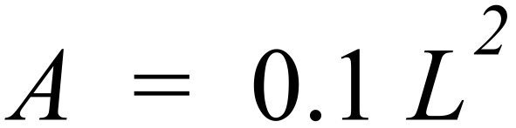 C. 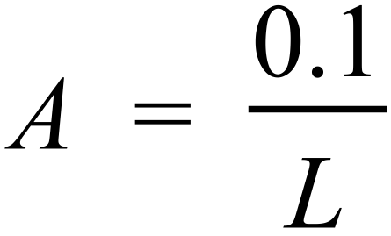 D. 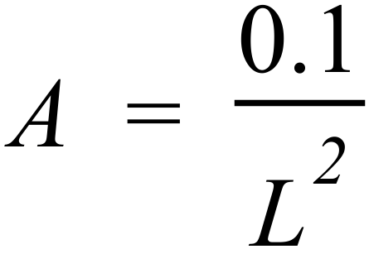
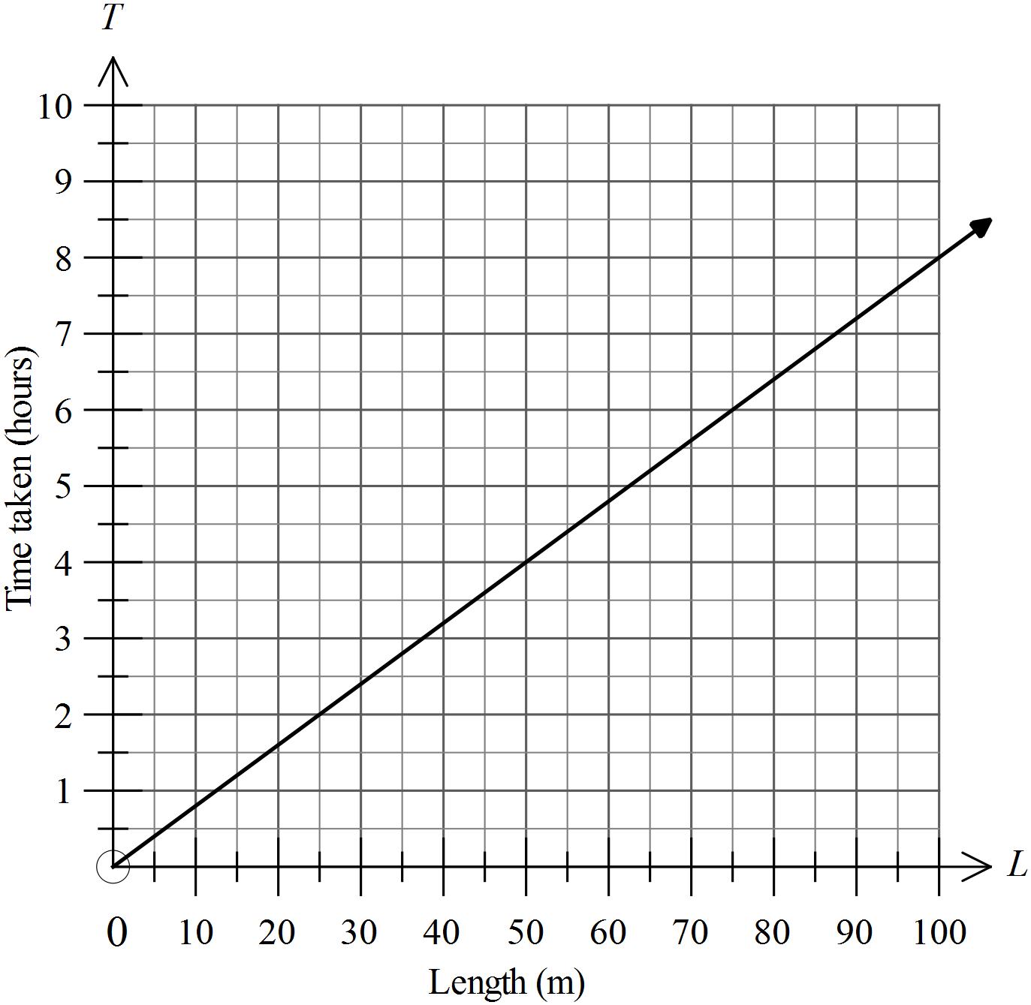Questions 2 and 3 refer to the following graph.
The graph shows the time (T hours) required to dig a ditch of a given length (L m).

How long would it take to dig a ditch which was 75 metres long?

A. 3 hours B. 4 hours C. 5 hours D. 6 hours
What is the equation which describes the proportion?

A.  B. 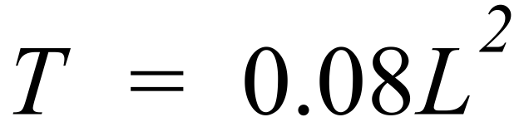 C.  D. 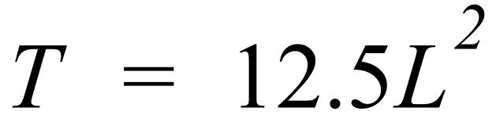
Questions 4 and 5 refer to the following graph.
The graph shows the number of spectators in a football stadium, from the time the gates were opened for a match, till the last spectator leaves.
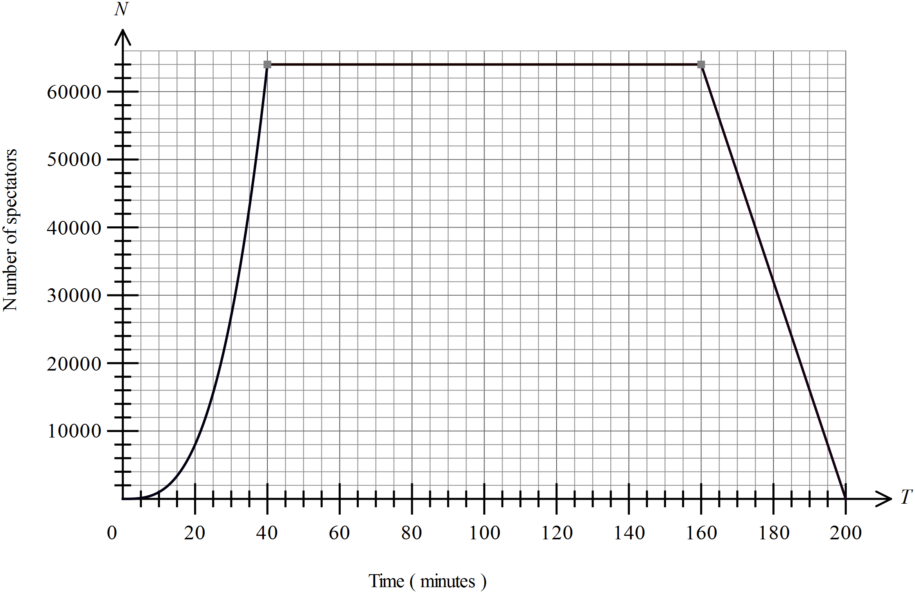

How could you describe the way the stadium filled?
A. There was a fast rush of spectators at first, but the rate quickly decreased to a trickle.
B. There was a slow trickle of spectators at first, but the rate quickly increased to a rush.
C. There was a rush at first which slowed to a trickle then quickly increased again.
D. There was a slow trickle at first which increased to a rush then quickly decreased again.
At what rate did the stadium empty (in spectators per minute)?
A. 400 B. 800 C. 1600 D. 6400
Questions 6 – 8 refer to the following graph.
The distance/time graph shows the expedition by a delivery truck, leaving its depot, making three deliveries and returning to the depot at the end of the day.
Two of the deliveries were made while travelling away from the depot and one while returning.
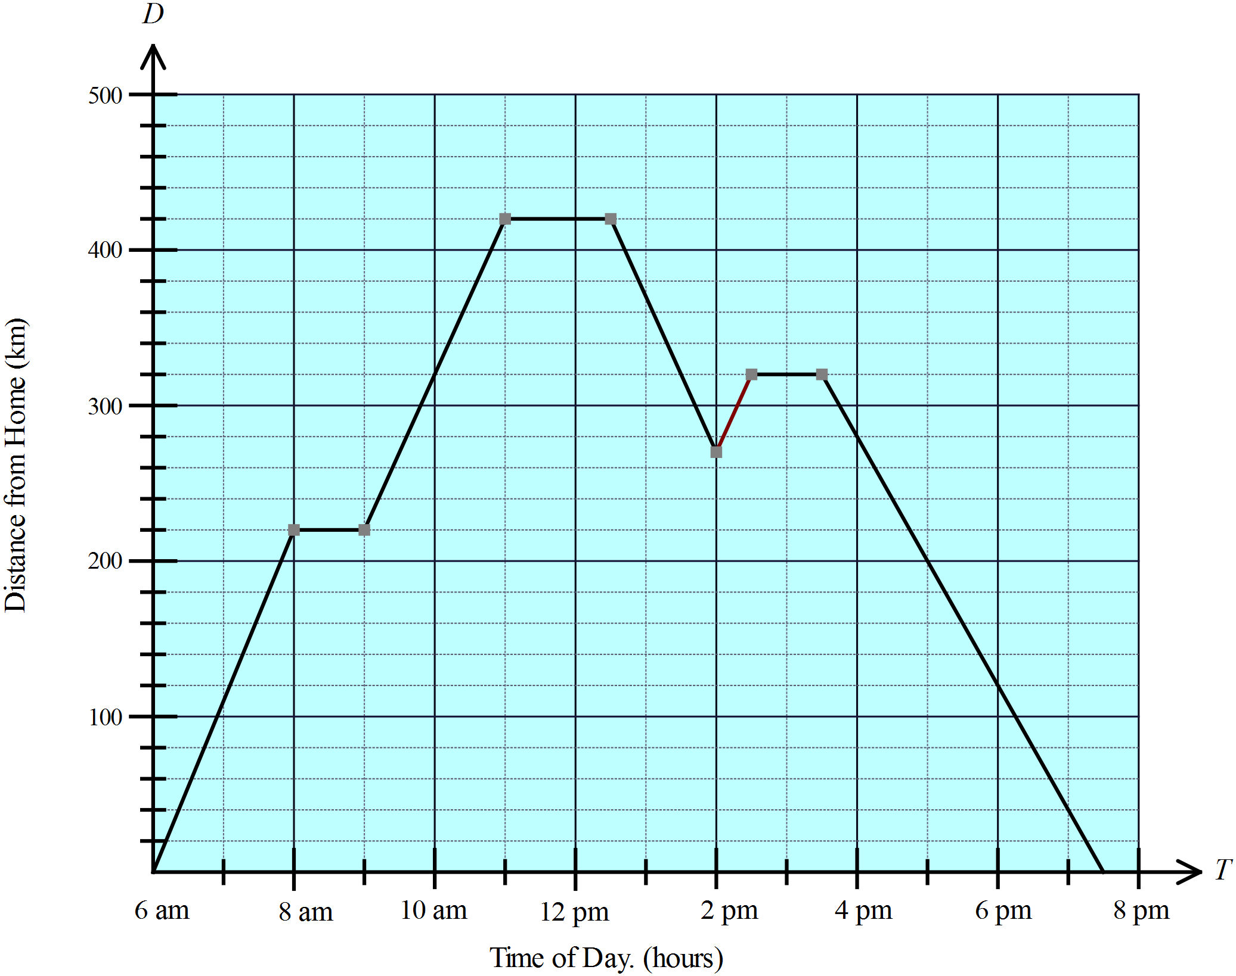

In going to one of the deliveries, the truck went past the delivery point and had to go back.
At what time did he turn around to go back to make the delivery?

A. 8:00 am B. 11:00 am C. 12:30 pm D. 2:00 pm
What was the trucks speed between 9 am and 11 am?

A. 80 km/h B. 90 km/h C. 100 km/h D. 200 km/h
How far did the truck travel in the day?

A. 800 km B. 840 km C. 890 km D. 940 km
A tank is being filled from a hose. The depth (D cm) of water in the tank is directly proportional to the amount (A litres) of water that has passed through the hose. If the constant of proportion is x, which equation could describes this proportion?

A.  B. 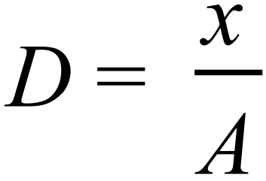

C. 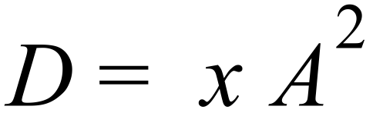 D. 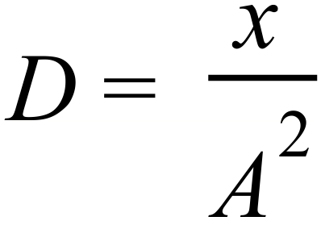
Kilwede herbicide is mixed by adding a concentrate to water. The amount of concentrate required is directly proportional to the amount of water. Nine litres of water require 360 ml of concentrate.
What is the equation for the amount of concentrate (C ml) required for a given amount of water (W litres)?

A. 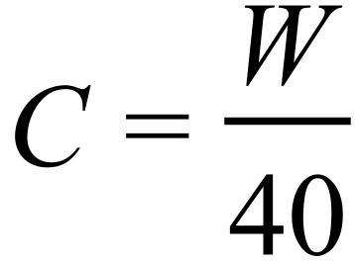 B. 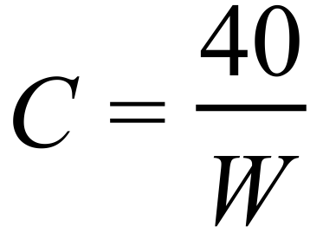

C.  D. 
The quantity (Q tonnes) of corn harvested from a square field is directly proportional to the square of the length (S m) of its sides.
A square field with sides 100m has a harvest of 4.5 tonnes.
What would be the harvest from a field with sides 600 m?

A. 27.0 tonnes B. 162.0 tonnes C. 243.0 tonnes D. 648.0 tonnes
P is directly proportional to the square of Q. Which graph illustrates this proportion?

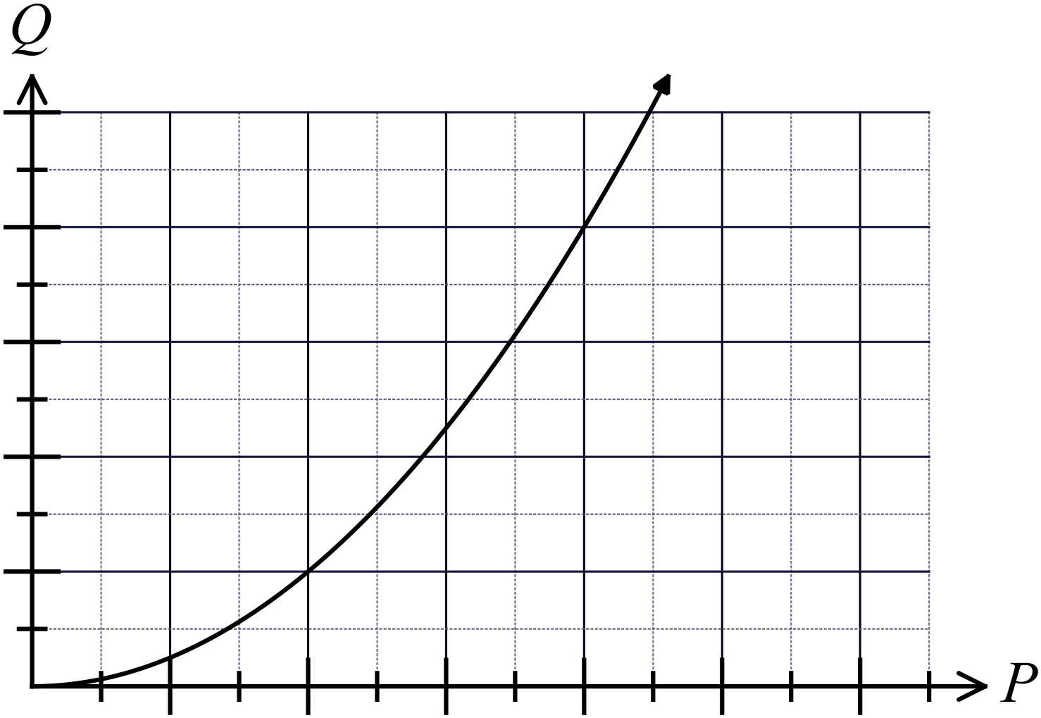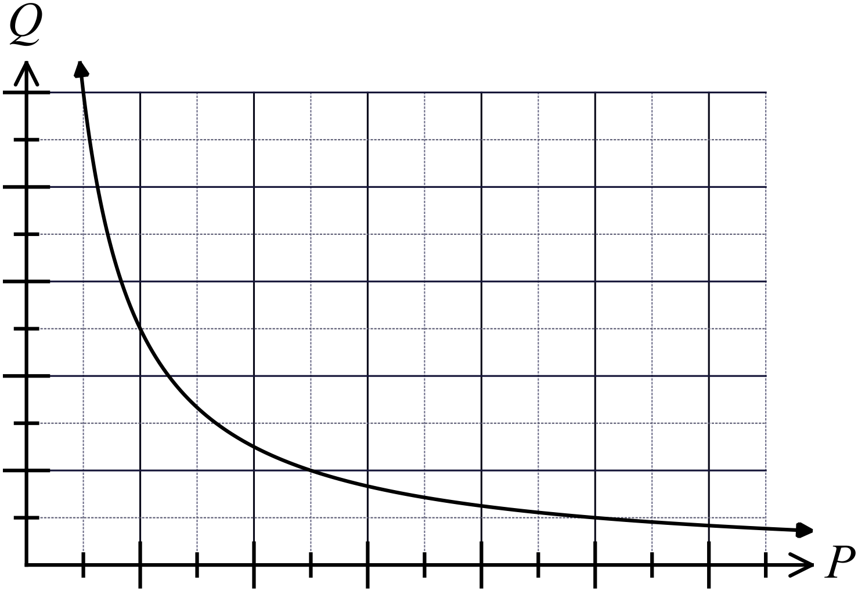A. B.

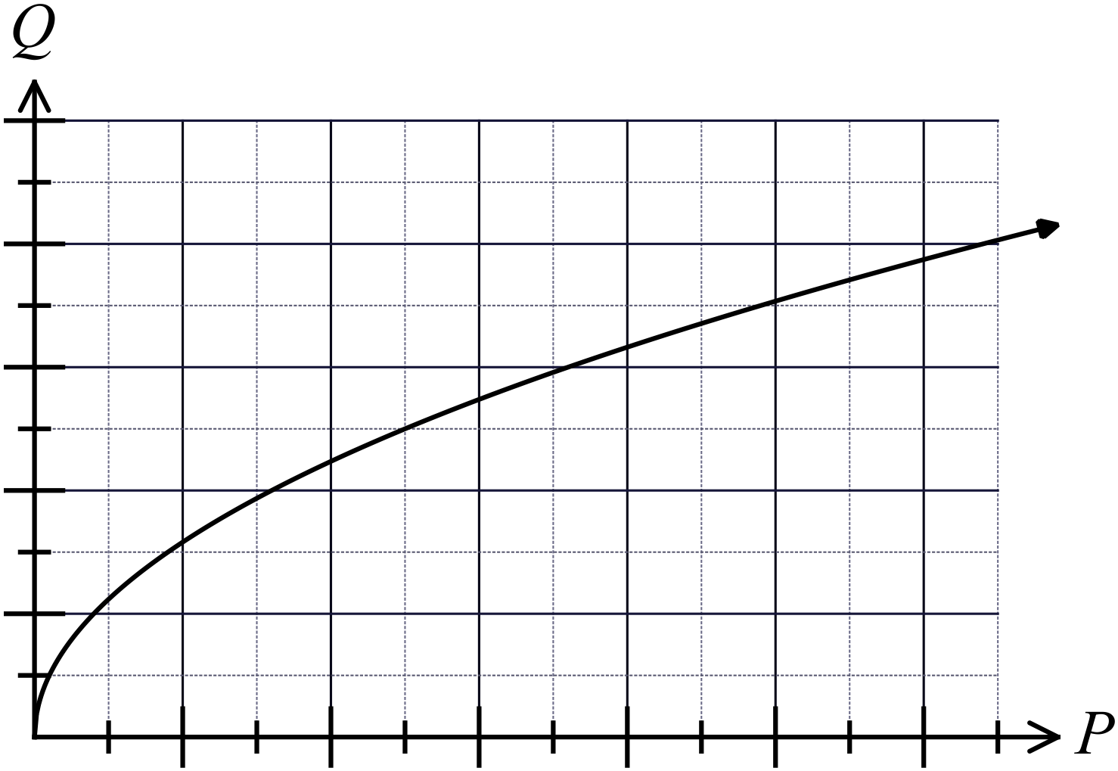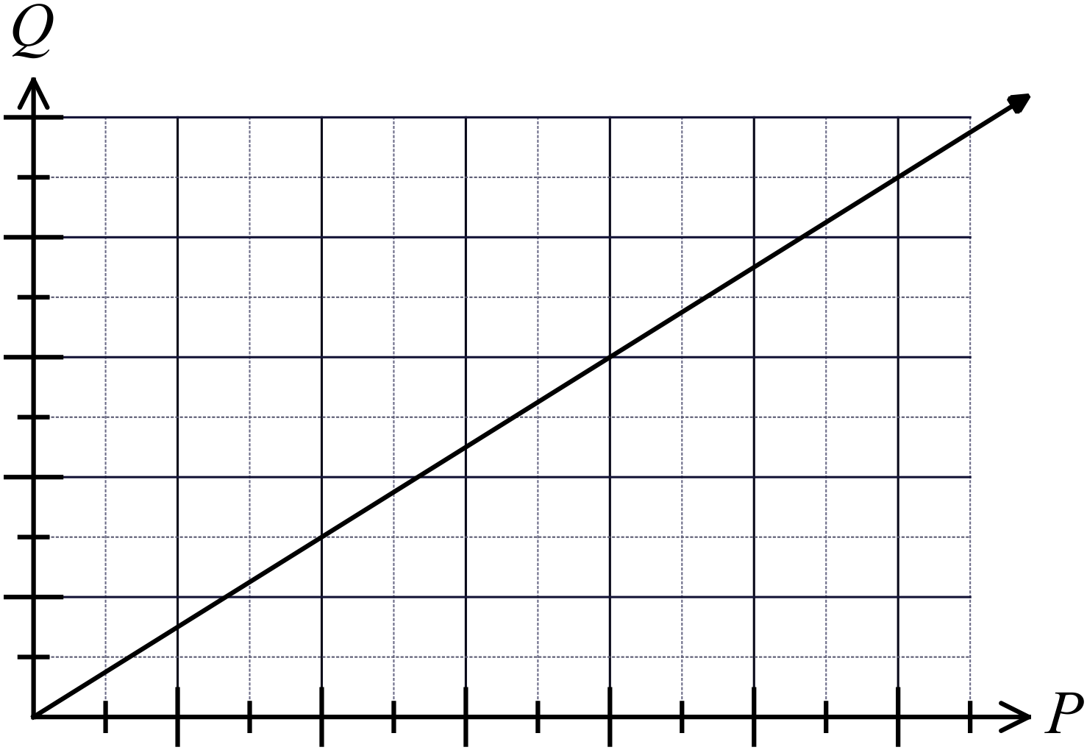C. D.

In which of these graphs is x inversely proportional to y?
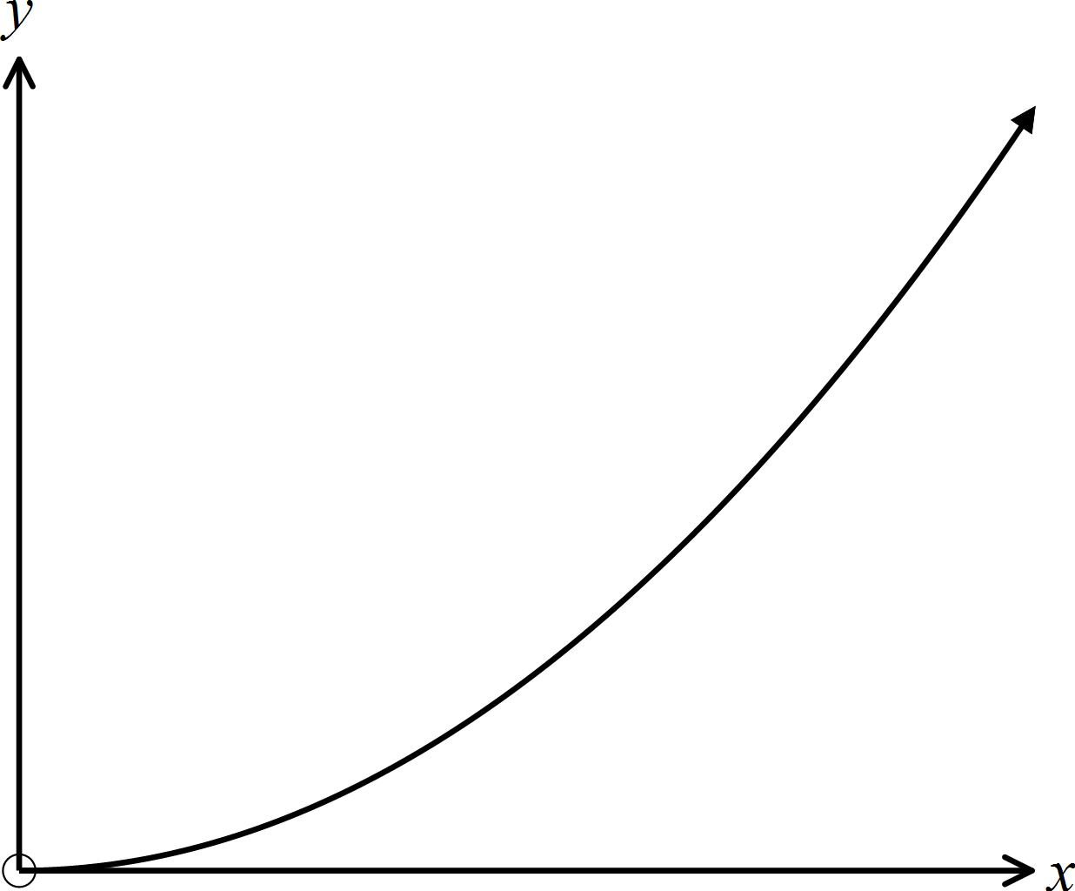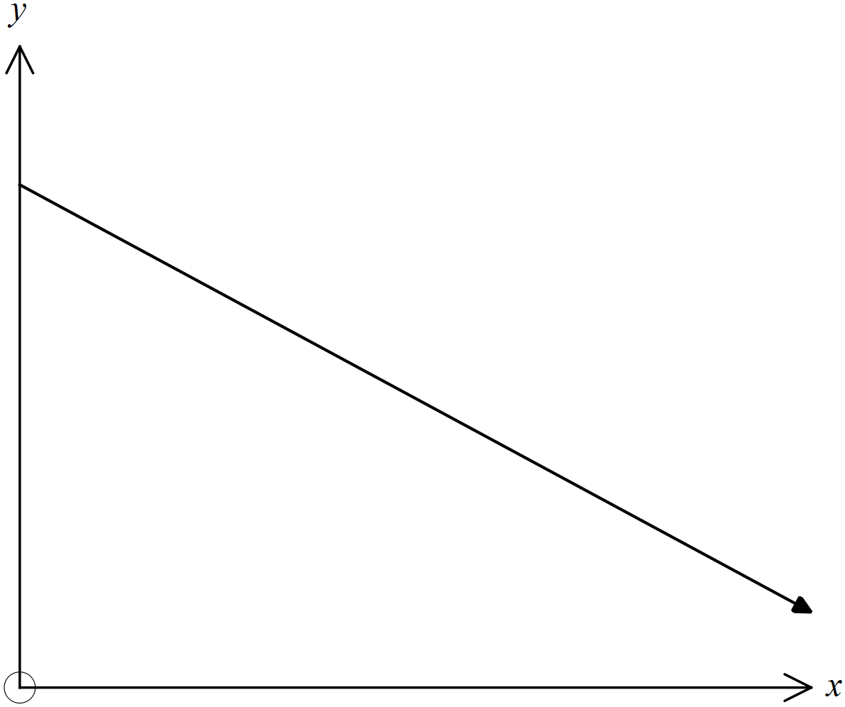 A. B.

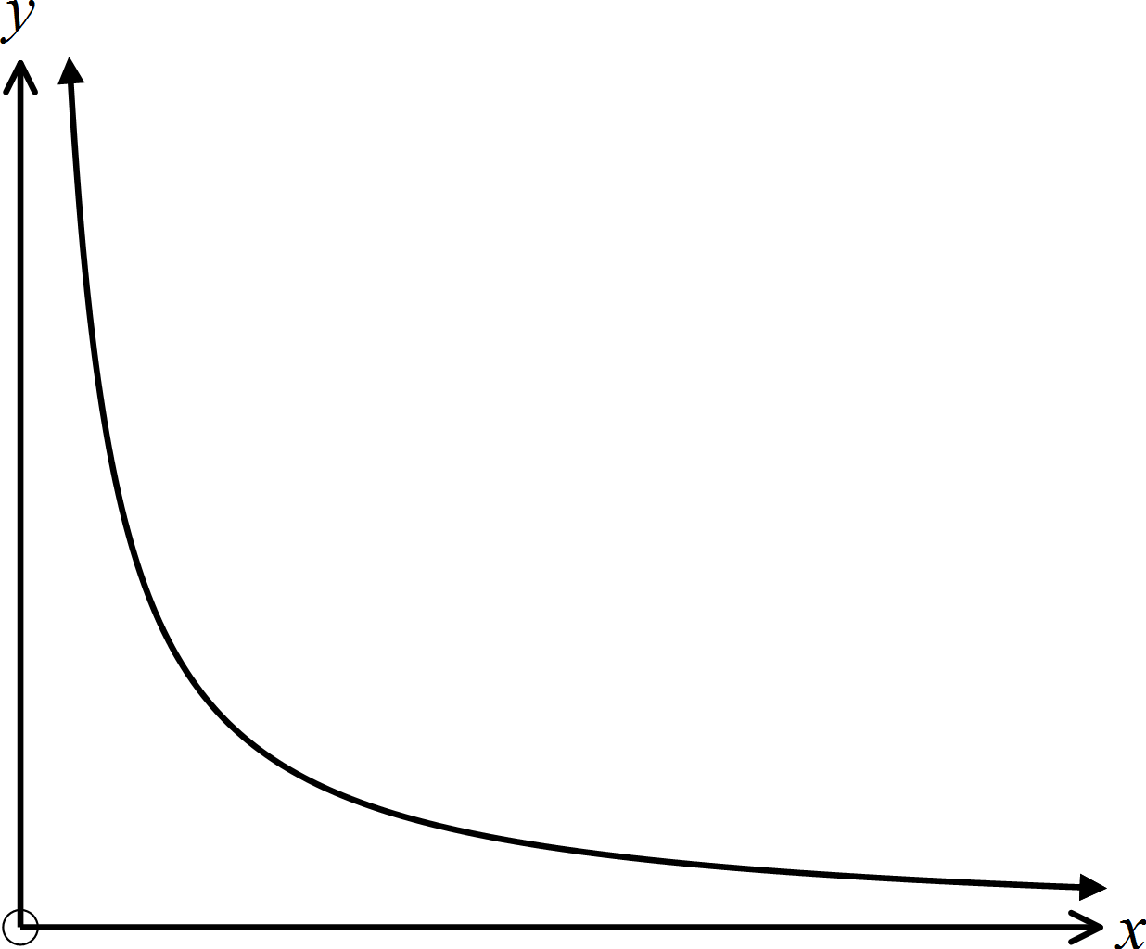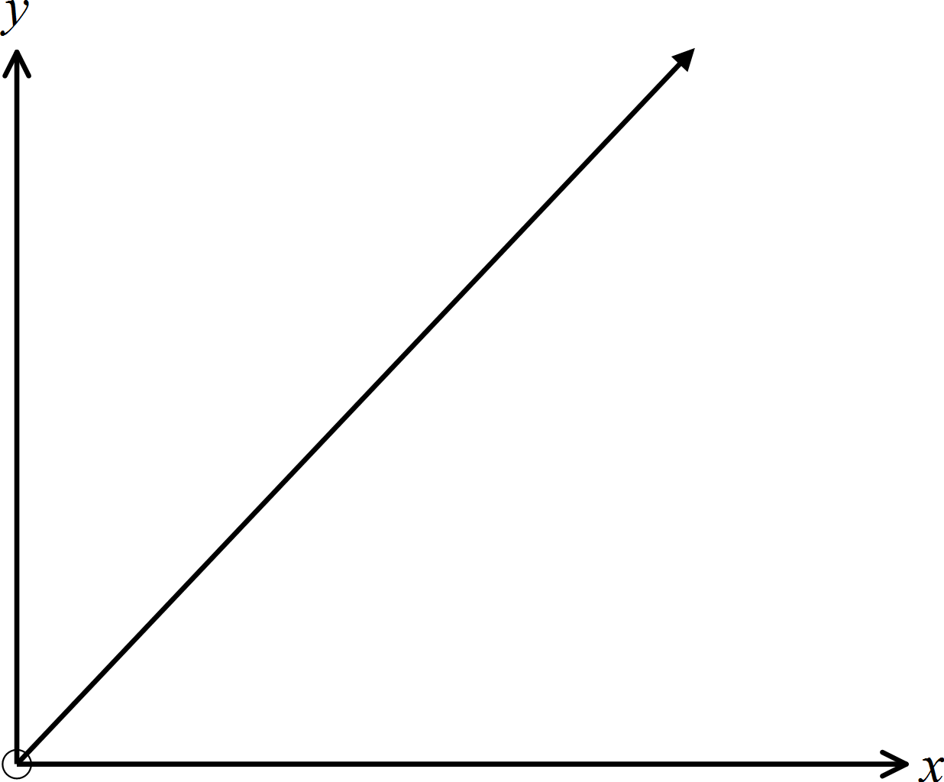C. D.

The time (T) taken for a 100 km journey is inversely proportional to the speed (S) of the vehicle.
Which of these could be the equation that describes this relationship

A. 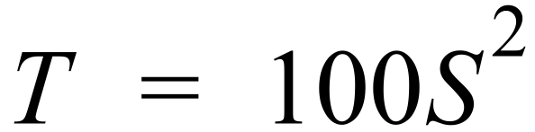 B.  C. 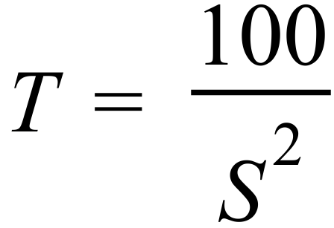 D. 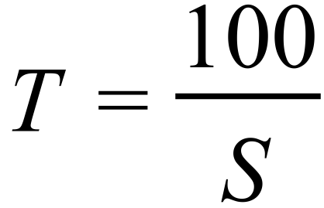
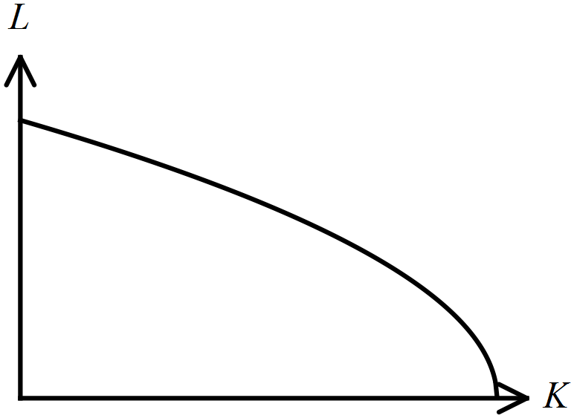The graph shows the relationship between L and K.

A. L is decreasing at a decreasing rate relative to K.
B. L is decreasing at an increasing rate relative to K.
C. L is increasing at a decreasing rate relative to K.
D. L is increasing at an increasing rate relative to K.
M is inversely proportional to the square of G.
If M = 2 when G = 16, what is the equation which describes the proportion?

A. 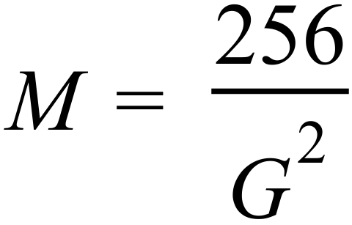 B. 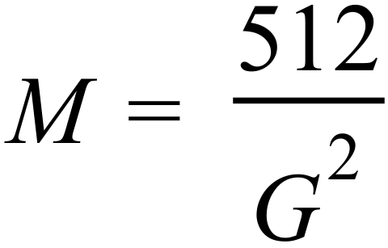 C. 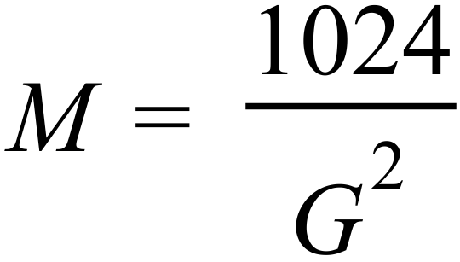 D. 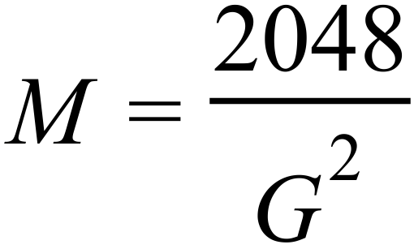

Multiple Choice Answer Sheet
Proportion
Name _____________________________________________
Completely fill the response oval representing the most correct answer.

1. A B C D
2. A B C D
3. A B C D
4. A B C D
5. A B C D
6. A B C D
7. A B C D
8. A B C D
9. A B C D
10. A B C D
11. A B C D
12. A B C D
13. A B C D
14. A B C D
15. A B C D
16. A B C D
Year 10 |  | Proportion | Non Calculator
Section 1 Short Answer Section
ANSWERS
No. | WORKING |  | ANSWER
 | 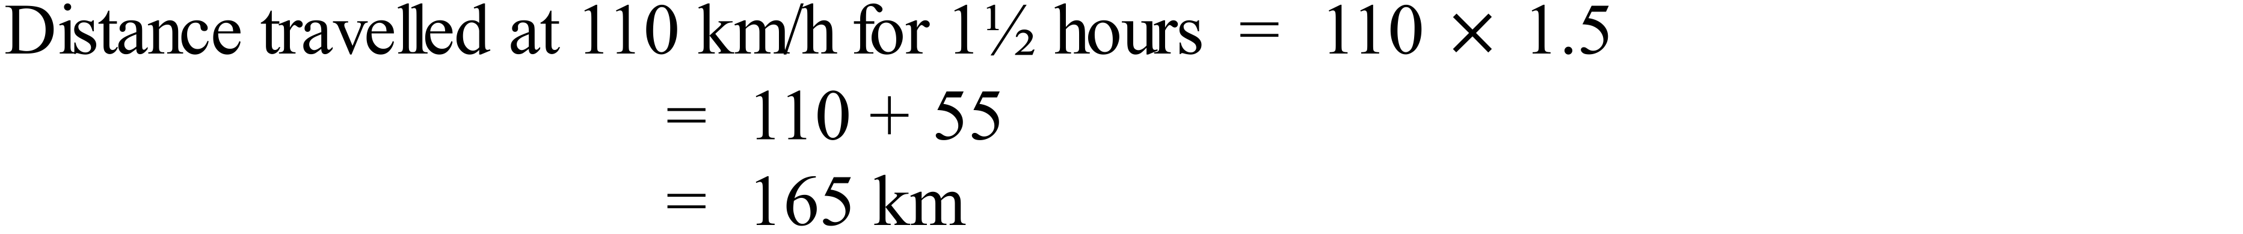 |  | 165 km
 | 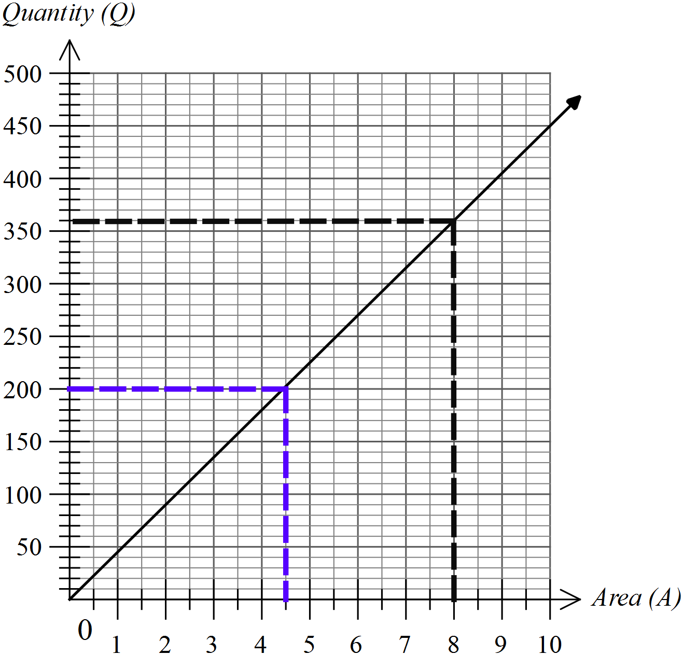  When A = 8 Q = 360 from graph (black broken line) |  | 360 litres
 | When Q = 200 A = 4.5 from graph (blue broken line) |  | 4.5 Hectares
 | The section from B to C is steeper than others, so indicates the cyclist is going quicker, hence it is probably downhill |  | Downhill
 | Between D and E the graphs drops down indicating the cyclist changes direction, maybe to go back for something dropped or any other viable reason. |  | Turned around and went back for some reason
 | Steepest section of the graph is the fastest, so between F and G |  | F and G
 | 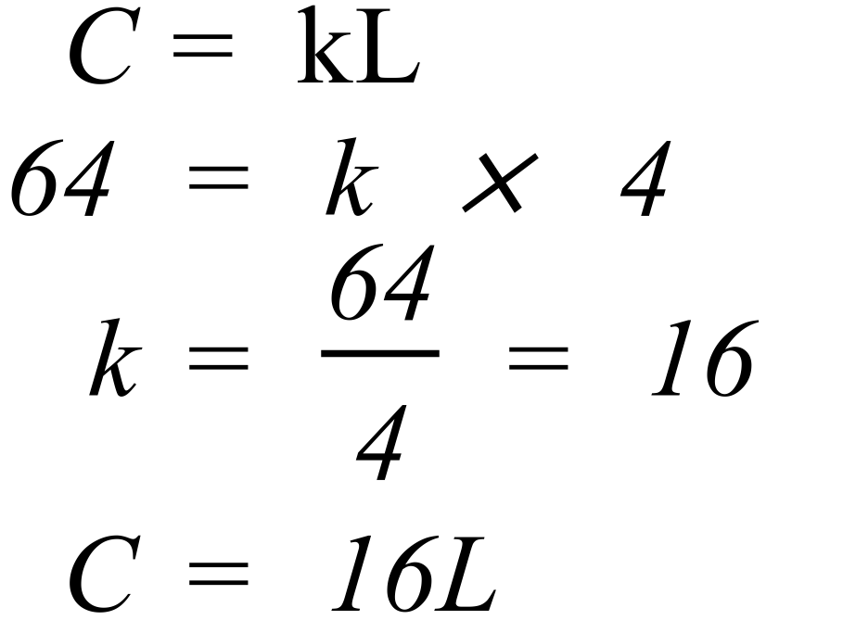 |  | 
 | 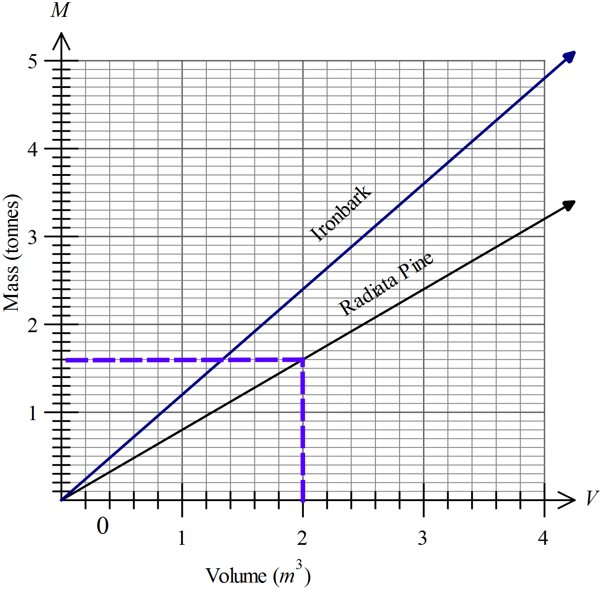  Mass of 2m³ = 1.6 tonnes. ( blue line on graph) |  | 1.6 tonnes
 | 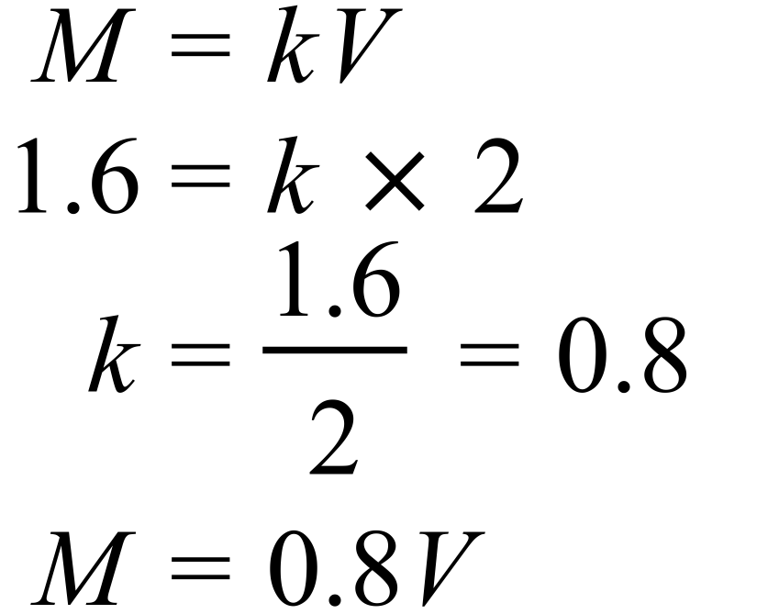 |  | 
 | 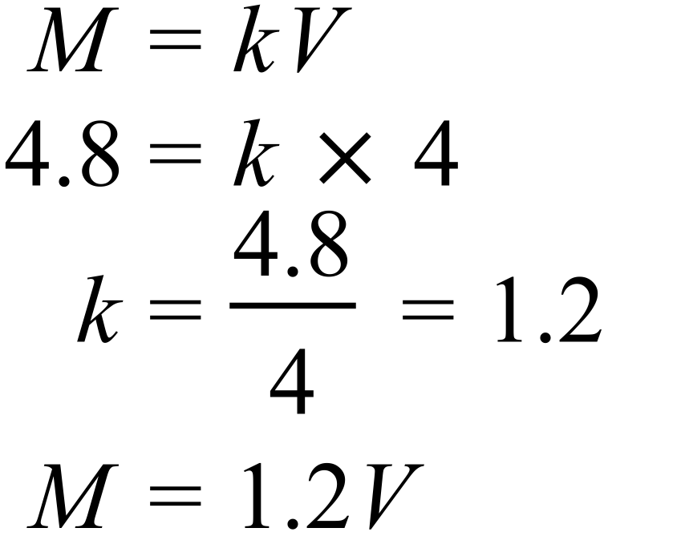See graph |  | See coloured line for ironbark on the graph
 | He arrived at 10 am and left at 12 pm |  | He arrived at 10 am and left at 12 pm
 | The first bus is faster, travelling 20 km in half an hour.  Speed = 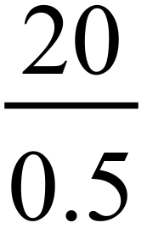 = 40 km/h |  | 40 km/h
 | Horizontal section between first two buses is about a quarter of an hour |  | A quarter of an hour
 | 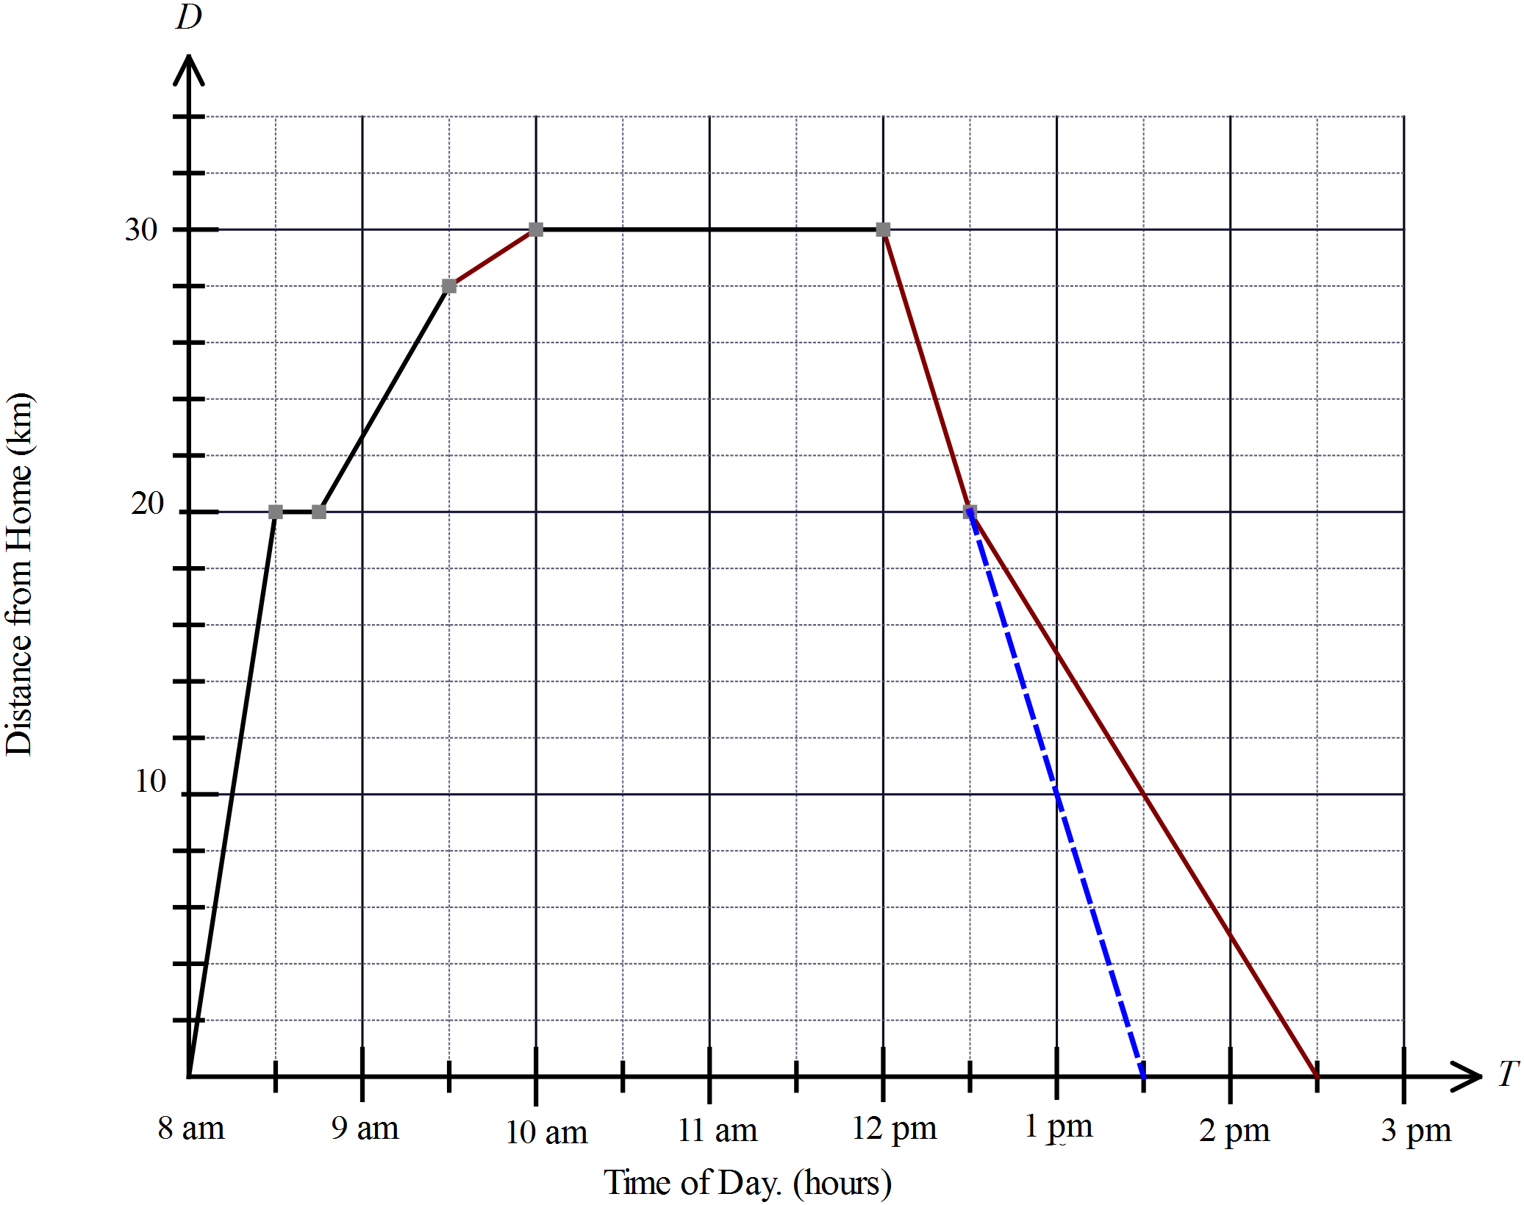  Continue line down from bus, would have arrived at 1:30 pm, but he arrived at 2:30 pm, so would have arrived an hour earlier.  Or done by calculating speeds. |  | 1 hour earlier
 | 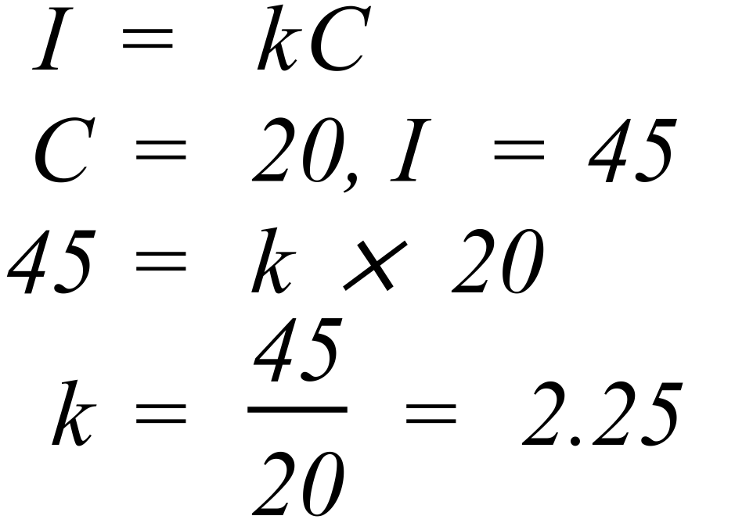 |  | k =2.25
 | 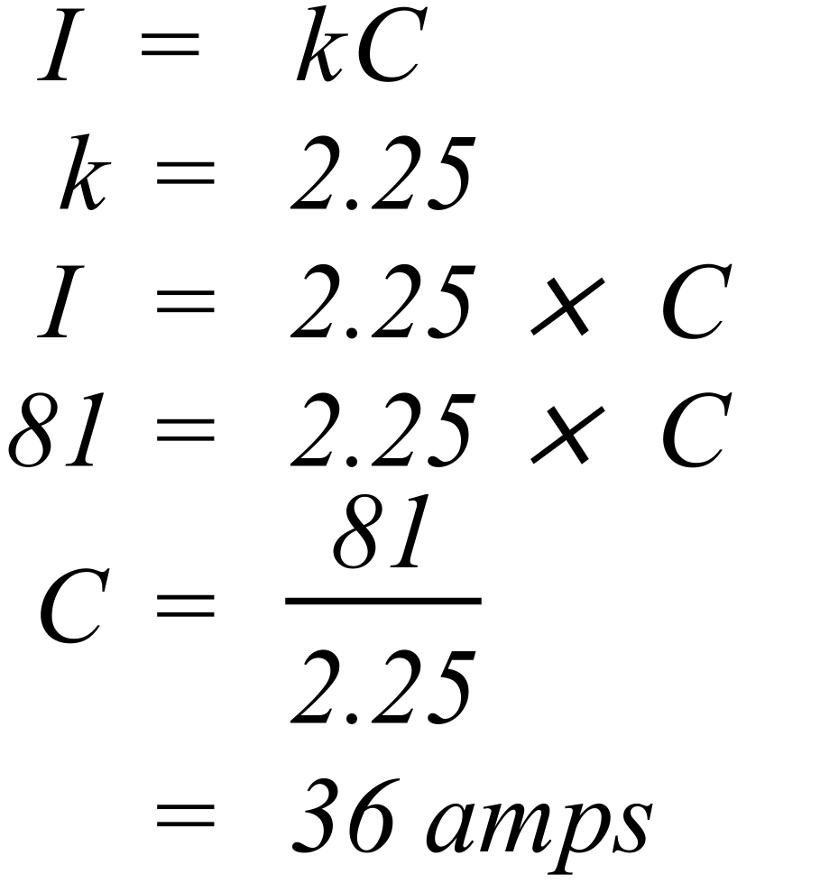 |  | 36 amps
 | Any two numbers with a product of 72, where both are greater than or equal to 2.  e.g. 2 and 36  3 and 24  4 and 18  6 and 12  8 and 9 |  | Any 2 or these shown at left
 | 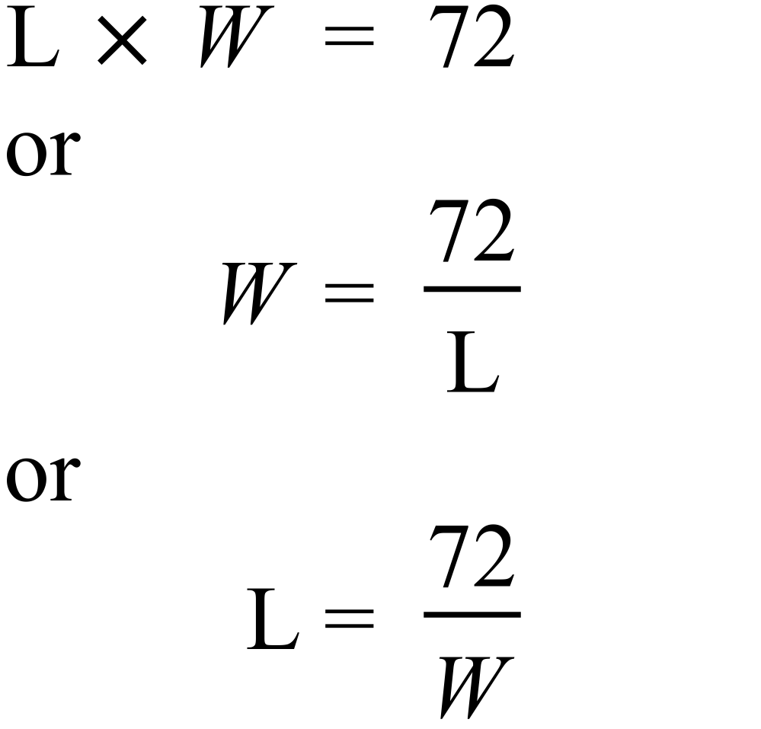

Year 10 |  | Proportion | Calculator Allowed
Section 2 Multiple Choice Section
ANSWERS
No. | WORKING |  |  | ANSWER
 | 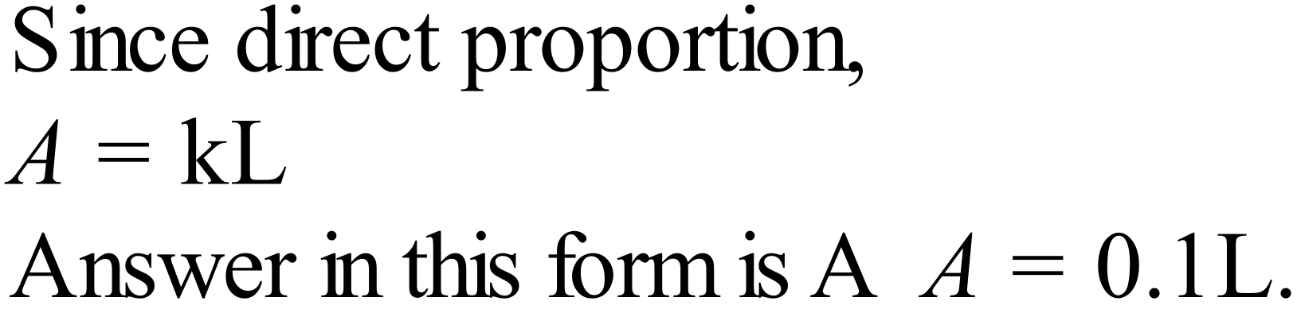 |  |  | A
 | 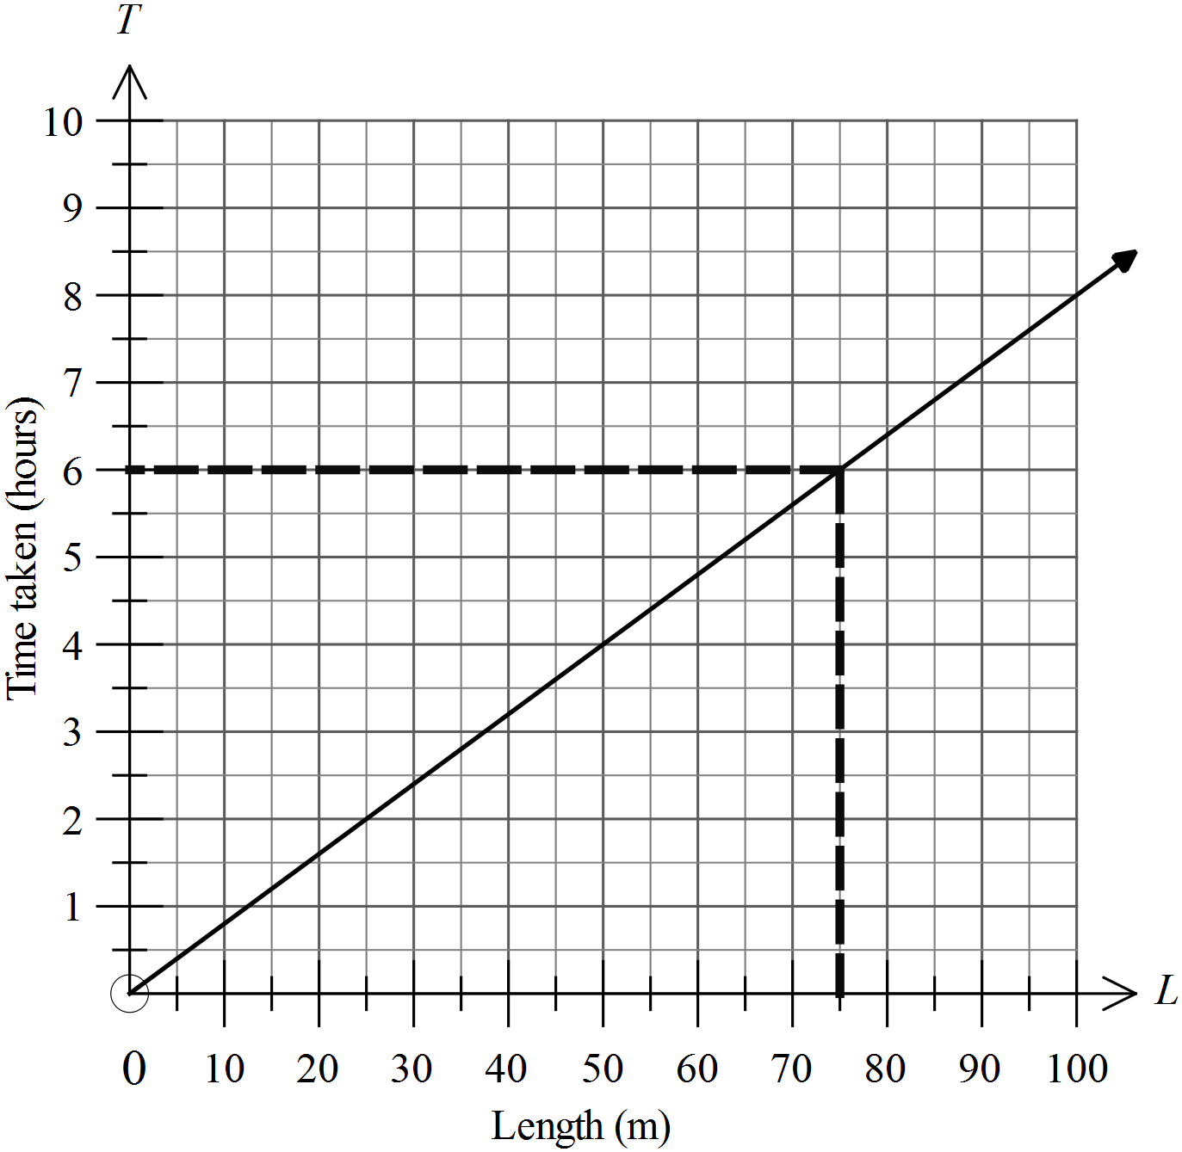  From graph, L = 75 gives T = 6. |  |  | D
 | 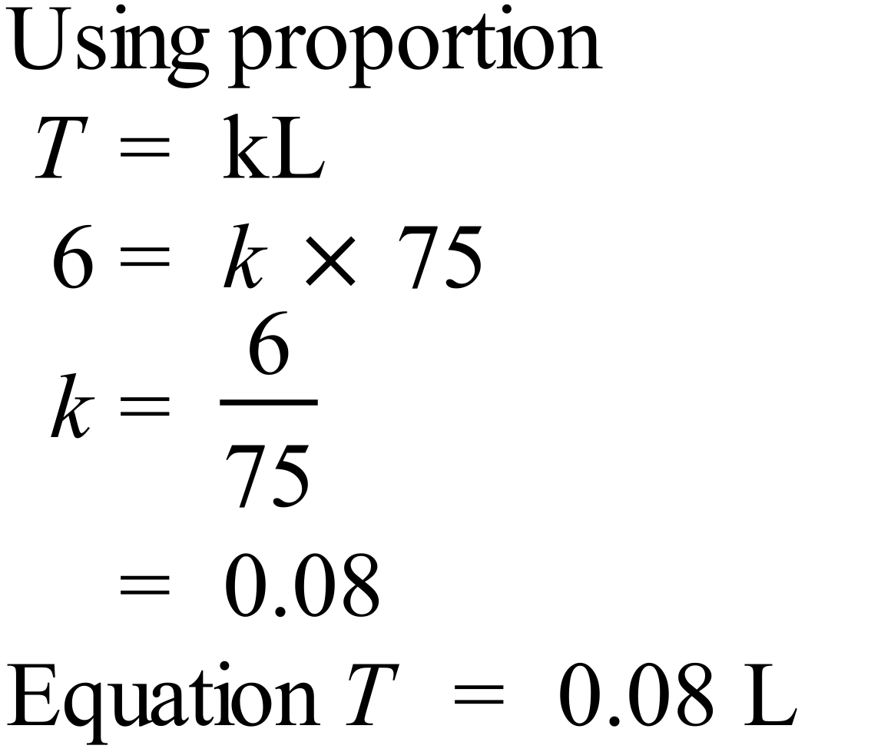 |  |  | A
 | The low gradient initially indicates a slow trickle, but this rises very steeply indicating a rush which continues till the stadium is full. |  |  | B
 | 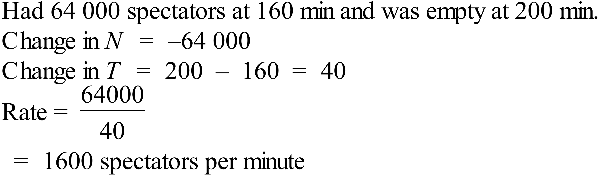 |  |  | C
 | Turns around where there is a change in direction of the graph from up to down (or vice versa as in this case) This occurs at 2 pm. |  |  | D
 | 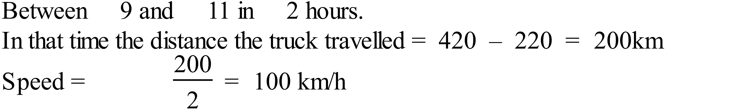 |  |  | C
 | 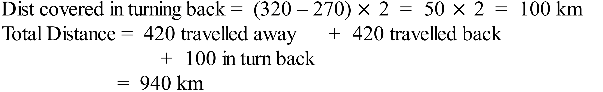 |  |  | D
 | Directly proportional so  |  |  | A
 | 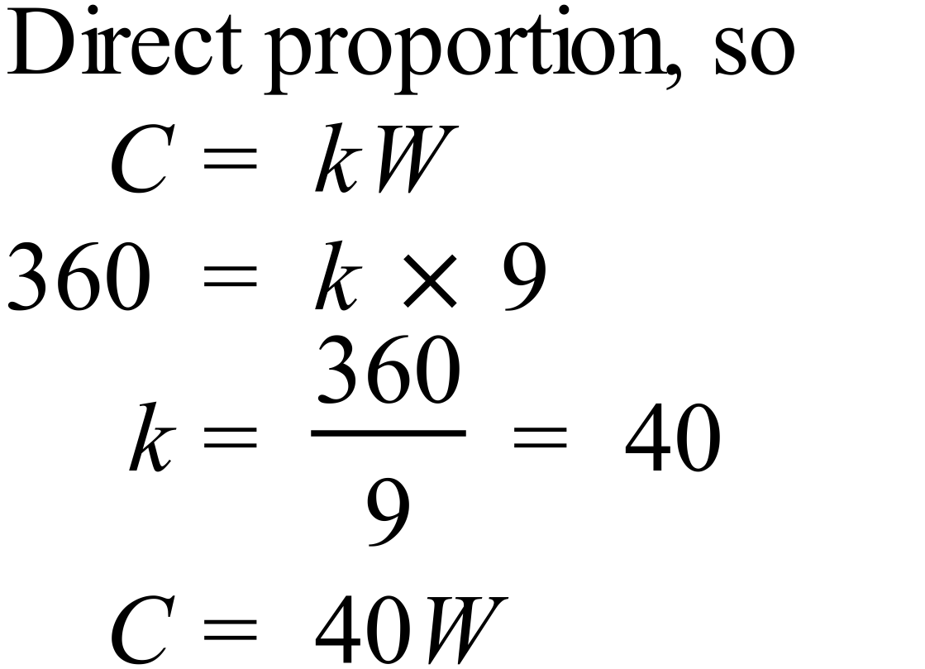 |  |  | C
 | 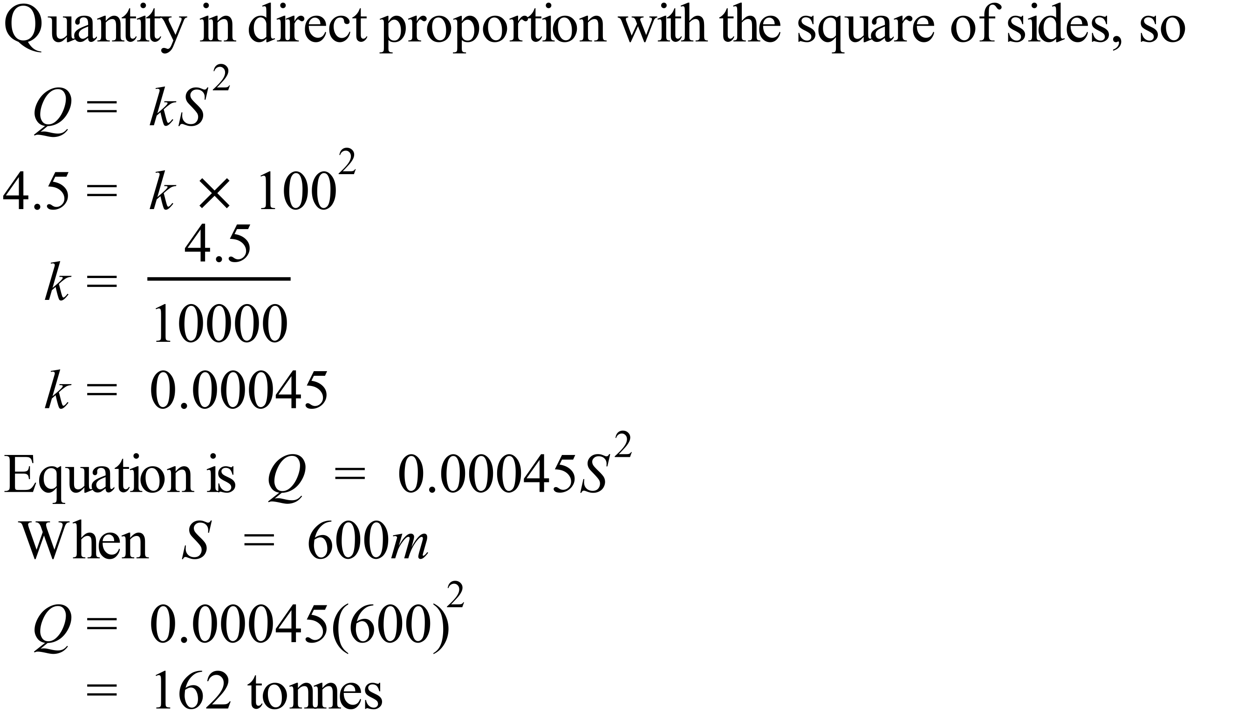 |  |  | B
 | P is directly proportional to the square of Q, so P increases as Q increases, but at an increasing rate. ( the steepness increases) |  |  | A
 | In inverse proportion gives a hyperbolic shape, which is C. |  |  | C
 | 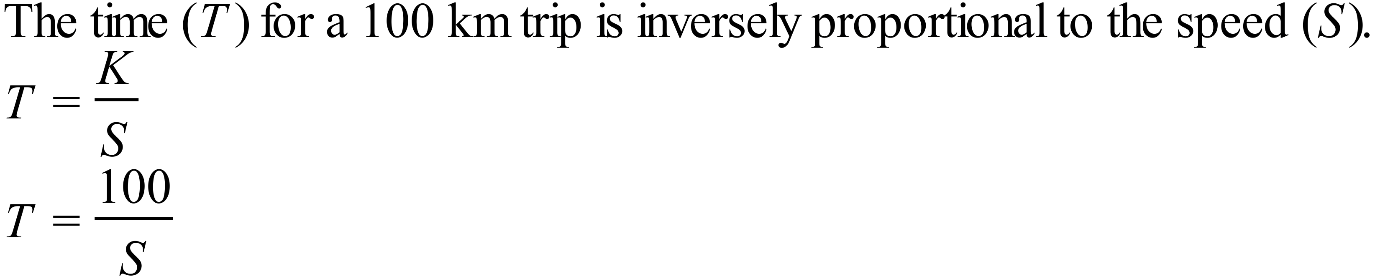 |  |  | D
 | The graph of L is going down as K increases, so in decreasing.  The graph gets steeper, so decrease is increasing.  Decreasing at an increasing rate. |  |  | B
 | M is inversely proportional to the square of G.  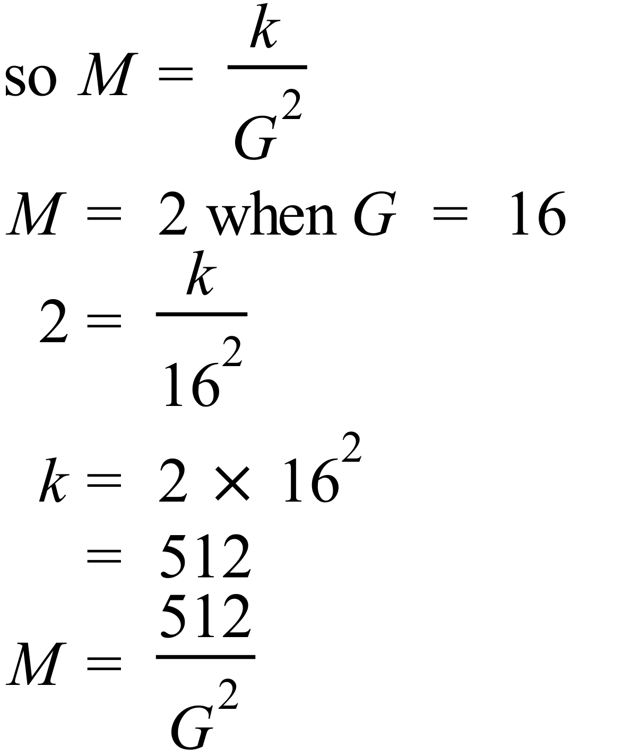 |  |  | B

Multiple Choice Answer Sheet
Proportion
Name _______ANSWERS_______________________________
Completely fill the response oval representing the most correct answer.

1. A B C D
2. A B C D
3. A B C D
4. A B C D
5. A B C D
6. A B C D
7. A B C D
8. A B C D
9. A B C D
10. A B C D
11. A B C D
12. A B C D
13. A B C D
14. A B C D
15. A B C D
16. A B C D

